BOLO Project Version 3

Final Deliverable

**Florida International University  
CIS 4911 Senior Capstone Project  
Software Engineering Focus**

**Team Members**Ryan del Rosario, *<*[*rdelr011@fiu.edu*](mailto:rdelr011@fiu.edu)*>*Rodney Sanchez, *<*[*rsanc172@fiu.edu*](mailto:rsanc172@fiu.edu)*>*

**Mentors**Juan Caraballo, IBM / FIU  
Robert Loredo, IBM / FIU

**Product Owners**Samuel Ceballos, Pinecrest Police Department, Police Chief  
Jason Cohen, Pinecrest Police Department, Major

**Instructor**Masoud Sadjadi, FIU

**Secondary Contributors**David Vizcaino, *<*[*dvizc002@fiu.edu*](mailto:dvizc002@fiu.edu)*>*

Copyright and trademark notices, restrictions on copying or distributing the documentation, information for contacting the issuing organization (reader’s comments), warranties, contractual obligations or disclaimers, and general warnings and cautions.

# Abstract

The mission of this project is to create a software product, usable, scalable and secure that helps on the process of the BOLO (Be on the lookout) creation fliers. This software will help police officers to fight crime in a more efficient, faster and easier way, by replacing the long and obsolete paper based process. With the use of this software not only will the officers serve better their communities but also the efforts of making the world a better and safer place won’t be in vain.

# Table of Contents

Contents

Abstract 2

Table of Contents 3

1 | Introduction 6

1.1 | Current System 6

1.2 | Purpose of New System 6

2 | User Stories 8

2.1 | Implemented User Stories 8

User Story # 404 - Add the archive link on each BOLO flier 8

User Story # 403 - Allow users to edit previously created BOLOs from homepage 8

User Story # 441 - Change source email when creating BOLO 8

User Story # 471 - Add ability to destroy Archived BOLO 8

User Story # 486 Add ability to restore a BOLO 8

User Story # 480 - Create new archive page 9

User Story # 459 - Ability for administrators to edit agency information 9

User Story # 452 - Remove unnecessary details and expand Summary/Additional Info Section 9

User Story # 494 - Overhaul BOLO preview 9

User Story # 519 - Redesign Alerts page 9

User Story # 493 - Ability for all users to filter alerts by agency 9

User Story # 461 - Add the category Recovered to the update drop down 9

User Story # 555 - Refactor Project Documentation 10

User Story # 548 - Refactor User Guide 10

User Story # 462 - Ability for Admin to delete Agencies 10

2.2 | Pending User Stories 10

3 | Project Plan 11

3.1 | Hardware and Software Resources 11

3.1.2 | Development Environment 11

3.1.2 | Deployment Requirements 12

4 | Sprints Plan 13

Sprint 1 13

Sprint 2 13

Sprint 3 14

Sprint 4 15

Sprint 5 17

Sprint 6 18

Sprint 7 20

5 | System Design 25

5.1 | Architectural Patterns 25

5.2 | Deployment Diagram 26

5.3 | Design Patterns 26

5.3.1 | Repository Pattern 27

5.3.2 | Adapter 27

5.3.3 | Observer 27

6 | System Validation 28

Glossary 32

Appendix 33

Appendix A: UML Diagrams 34

Dynamic UML Diagrams 34

Appendix B: User Interface Design 48

Appendix C: Sprint Review Reports 51

Sprint 1 Report 51

Sprint 2 Report 52

Sprint 3 Report 52

Sprint 4 Report 53

Sprint 5 Report 53

Sprint 5 Report 54

Sprint 6 Report 55

Sprint 7 Report 55

Appendix D: Sprint Retrospective Reports 57

Sprint 1 Retrospective 57

Sprint 2 Retrospective 58

Sprint 3 Retrospective 58

Sprint 4 Retrospective 59

Sprint 5 Retrospective 59

Sprint 6 Retrospective 60

Sprint 7 Retrospective 60

References 61

Tools, Frameworks, Platforms 62

# 1 | Introduction

A new web/mobile based application needs to be created for the Pinecrest Police Department in order to assist police officers in the reporting and controlled information propagation of BOLO flyers once a crime is committed and they have to collect all the information. These BOLOs not only will be available in a shorter amount of time to different circles of police officers but also they will get notified instantly when a BOLO has been created or modified. Also information will be persisted in a web server for future reference of detectives assigned to the case.

## 1.1 | Current System

Currently the process of BOLO creation and distribution is not very efficient. When an officer is assigned to a crime scene they would need to fill up a paper report with all the information related to the crime, this information can end up as a BOLO. The process is not simple, after the officer in charge of the crime scene has finished the report, a copy is given to the supervisor in charge for review. Once completed the review and approval of the report, the supervisor will send it to bookkeeping where it will be handed to detectives, officers and sometimes other police agencies.

The briefly described process is slow and tedious as well as expensive, mainly because of the time it takes to successfully complete a distribute a complete BOLO and also the number of people that are part of this process. For example, if a crime is committed on Friday after working hours it will not be until Monday that the personnel will be notified to start working in it. Because is just a piece of paper is easier to get lost among other BOLOs for example or even be forgotten.

## 1.2 | Purpose of New System

There are several goals of the new system. Decreasing the time needed for an officer to collect the information and turn it into a usable piece of information (BOLO), the new system will allow officers not only to create bolos with greater ease than never before but also to view Bolos belonging to other departments or agencies in a single place. The system will also help in the notification since emails will be sent to the group of officers selected once a bolo has been created or modified. As mentioned before, all the BOLOs will be kept online at all times which means anyone authorized could access them from almost any device with an internet connection. Another strong point is that the management of the BOLOs will be handled in a more efficient and responsive way by the supervisors, having the ability of editing and removing BOLOs from the system.

# 2 | User Stories

This section will show the user stories implemented during the version 3 of this product. There will not be any carry over user stories since all the functionality requested by the product owners was successfully turned in on time.

## 2.1 | Implemented User Stories

### User Story # 404 - Add the archive link on each BOLO flier

As an admin user, I would like to click on an archive link, so that I can archive directly from the homepage.

### User Story # 403 - Allow users to edit previously created BOLOs from homepage

As a user, I would like to see an “Edit” link on a BOLO, in the homepage, in order to more efficiently and easily update the BOLOs.

### User Story # 441 - Change source email when creating BOLO

As a user, I would like to be able to receive an email confirmation when a BOLO flier is created, so that all users can receive a notification of any new BOLO.

### User Story # 471 - Add ability to destroy Archived BOLO

As a user, I would like to see a “Delete” link on a BOLO, in the Archive page, in order to easily delete a BOLO from the database.

### User Story # 486 Add ability to restore a BOLO

As a user, I would like to see a “Restore” link on a BOLO, in the Archive page, in order to more

efficiently and easily activate a BOLO and show it on the homepage.

### User Story # 480 - Create new archive page

As a user, I would like to view all Archive BOLOs on a page, so I can now see all previously archive BOLOs.

### User Story # 459 - Ability for administrators to edit agency information

As an administrator, I would like to be able to edit information on all agencies, so that I may better manager all agencies in the system.

### User Story # 452 - Remove unnecessary details and expand Summary/Additional Info Section

As a user, I would like to be able to create BOLOs while providing only relevant information in a manner that suits my needs, while having the data still remain readable to users.

### User Story # 494 - Overhaul BOLO preview

As a user, I would like to be able to create BOLOs while providing only relevant information in a manner that suits my needs, while having the data still remain readable to users.

### User Story # 519 - Redesign Alerts page

As a user, I would like to see all the agencies in the Alert’s page, so I would be able to choose the agencies that I would like to receive notifications from.

### User Story # 493 - Ability for all users to filter alerts by agency

As a user, I would like to receive email alerts for BOLO pertaining only to the agencies that I select, so that I can reduce the amount of unnecessary emails I receive.

### User Story # 461 - Add the category Recovered to the update drop down

As a user, I would like to have a category to the update dropdown, so I can see all the recovered BOLOs

### User Story # 555 - Refactor Project Documentation

As a user, I would like to have a document where all the project information is at, so I can have details on what was done on the project during the semester.

### User Story # 548 - Refactor User Guide

As a user, I would like to have a user guide for each tier of users, so I can have a better understanding of the functionality each user can perform on the application.

### User Story # 462 - Ability for Admin to delete Agencies

As an administrator, I would like to have the ability to delete an agency, so I can better manage the current active Agencies.

## 2.2 | Pending User Stories

All user stories requested by the product owner were successfully delivered in the version 3 life cycle of the application.

# 3 | Project Plan

We were asked to develop the application on a specific technology stack, mainly Bluemix, Nodejs, ExpressJS and Cloudant. The plan is to start migrating to these new technologies the most important functionalities implemented by previous version of this software, mainly in WordPress and then if still have time start implementing some new features as well as removing unwanted features from the current system. While all this happen we will also focus on solving any bug encountered and if time allows us we will refine some existing features to make them better.

## 3.1 | Hardware and Software Resources

In order to develop and deploy the application some hardware and software is required. The following sections will describe the environments needed.

### 3.1.2 | Development Environment

In order to develop the application, the follow hardware specs are recommended:

* PC or Apple based Computer
* 8Gb of RAM
* 1 TB of disk space
* At least 2.0 Ghz processor

For software, developers will need the following:

* NodeJS 4.2+
  + NodeJS is a Javascript runtime environment which is used in the project as the main development language
* NPM
  + NPM is a package management tool required to install project dependencies required for executing the application in the NodeJS environment
* We recommend using Google Chrome even though the application will work any other browser.

### 3.1.2 | Deployment Requirements

The project is targeted for deployment on the IBM Bluemix Platform-as-a-Service Cloudfoundary environment. Besides an IBM Bluemix account the following is also required.

* Cloudant NOSQL Database
  + Access tokens are required to be set as environment variables for the application to work in both deployment and development.
* SendGrid
  + This is the service the application uses for sending notifications. Again, access keys are required in order for the application to work in both deployment and development environments.

## 4 | Sprints Plan

The following is a log of meeting summaries for sprint planning sessions. Throughout the project semester the team completed 7 sprints. Each Sprint section includes the date of the sprint planning meeting, a short summary, assigned user stories and tasks planned for the sprint.

## Sprint 1

(09/01/2015 - 09/11/2015)

The objective of this version is to create a real pilot. It was explained that, while Juan, Robert and David can provide technical mentorship, the true source for what needs to be done comes from the Police, i.e. Captain Samuel Ceballos and Major Jason Cohen. Also, any IP Intellectual Property) will be attributed to the Police. David has been working on the re-engineering of the BOLO application and can help us to understand what has been done.

**User Story # Learn Project Technologies**

***Tasks***

* Get Bluemix accounts setup and request to be added to the BOLO project
* Ask Professor Masoud for our Bluemix promo codes
* Schedule some time with David to get up to speed

…

***Acceptance Criteria***

* N/A

## Sprint 2

(09/12/2015 - 09/25/2015)

**User Story #578 Officer Creates a BOLO**

***Tasks***

* Create BOLO repository functionality
* Create BOLO service functionality
* Create jade view

***Acceptance Criteria***

* Create BOLO link should appear on menu for users with the proper permission
* When the user clicks the link it should be redirected to the create BOLO page
* User should fill up all the information referring to the bolo and click Submit
* On Submit the information should be stored into the database
* On success user is redirected to the BOLO listing page
* On failure user is notified

## Sprint 3

(09/28/2015 - 10/10/2015)

**User Story #587 Thumbnails Preview**

***Tasks***

* Express Routing for List BOLOs
* List BOLO page template
* Retrieve BOLO from Cloudant

***Acceptance Criteria***

* The system will show a thumbnail preview the last 24 BOLOs created
* The thumbnail will look like a 100 by 100 pixel box with the category of the BOLO on top, the picture associated with the BOLO below, and the date the BOLO was created at the very bottom

**User Story #588 Upload picture**

***Tasks***

* Research Services and Strategies
* Implement the strategy

***Acceptance Criteria***

* Picture uploaded
* Picture displayed in the flier with an acceptable size

## Sprint 4

(10/11/2015 - 10/22/2015)

**User Story #577 Delete BOLO**

***Tasks***

* Add Delete BOLO Application Service Layer Method
* Add Server Side Routing for Delete BOLO Feature
* Implement Storage Service Method to Delete BOLO from Cloudant
* Test End-to-End
* Update Web Client Interface Templates

***Acceptance Criteria***

* Only Tier 2 user and Administrator are able to delete any BOLO

**User Story #596 Edit BOLO**

***Tasks***

* Add Server Side Routing for BOLO Edit feature
* Create Edit Bolo Template
* Implement Application Service method to retrieve BOLO by ID
* Implement Storage Service method to update BOLOs on Cloudant

***Acceptance Criteria***

* Edit the BOLO, and be able to save it

**User Story #597 Login**

***Tasks***

* Add Server Side Login Routing
* Create Login Page Template
* End-to-End Testing
* Implement Application Layer Authorization Interface
* Implement Cloudant User Repository
* Implement Login Session Storage
* Implement User Domain Objects
* Research Node.js and Express Authentication

***Acceptance Criteria***

* Users are prompted for their log in information when they navigate to the webpage
* Users are able to log into the system with valid credentials

**User Story #599 Log out button**

***Tasks***

* Add Logout button when logged in
* Add Server Side Routing
* Implement Web Server Session Destroy method

***Acceptance Criteria***

* All users have a way to log out of the system

## Sprint 5

(10/23/2015 - 11/08/2015)

**User Story #600 Mobile version**

***Tasks***

* Update Bolo List View
* Update Create Bolo View
* Update Homepage View
* Update Login View

***Acceptance Criteria***

* The website re-sizes and rearranges itself in order to be view-able from a mobile device’s web browser

**User Story #586 Users Group**

***Tasks***

* Create Acceptance Tests
* Create Application Service
* Create Cloudant Repository
* Create Express Route Middlewares
* Create Views
* Setup Cloudant Database

***Acceptance Criteria***

* Administrators are able to create user groups when a new agency joins the initiative
* Administrators are able to assign users to a user group
* Users can belong to only one user group

**User Story #614 View full image**

***Tasks***

* Create Acceptance Tests
* Implement BoloRepository getAttachment
* Implement BoloService getAttachment
* Refactor and Clean
* Update views with links and thumbnails

***Acceptance Criteria***

* When a user clicks on the image on the BOLO Flier, the full size image is opened in a new tab

**User Story #614 Navigation menu**

***Tasks***

* Create Acceptance Tests
* Modify Menu per user basis

***Acceptance Criteria***

* Users are able to see thumbnails of the BOLOs created in the last 24 hours (or the 20 more recent)
* User can access the create, search, browse, edit, delete pages from the home page

## Sprint 6

(11/09/2015 - 11/22/2015)

**User Story #592 User management**

***Tasks***

* Create Acceptance Tests
* Create Form Views
* Create menu layouts
* Create reset users’ password
* Create user tier promotion and demotion
* Create view user details
* Implement client side form validation
* Implement CloudantUserRepository methods
* Implement route middlewares
* Implement server side validation
* Implement User Details Update function
* Implement UserService registration method
* Refactor Tests

***Acceptance Criteria***

* Add users
* Delete users
* Modify users’ access

**User Story #680 Create/Edit agency**

***Tasks***

* Create Acceptance Tests
* Create agency domain object
* Create agency repository
* Create agency service

***Acceptance Criteria***

* Create agency and save it in the database
* Be able to edit an agency and persist the changes in the database

**User Story #673 List agencies**

***Tasks***

* Create Acceptance Tests
* Create listing functionality on the AgencyRepository
* Create listing functionality on the AgencyService
* Create agency list view

***Acceptance Criteria***

* All agencies are listed with the fields: agency name, Address, City, Zip, State, Phone
* Each listing has Edit and Delete buttons.

**User Story #594 View Bolo**

***Tasks***

* Create Acceptance Tests
* Create view BOLO functionality on the BoloRepository
* Create view BOLO functionality on the BoloService
* Create BOLO details view

***Acceptance Criteria***

* View the selected BOLO in details

## Sprint 7

(11/22/2015 - 12/04/2015)

**User Story #584 Add ability to destroy/archive BOLO**

***Tasks***

* Create Archive functionality on BOLORepository
* Create Archive functionality on BOLOService
* Create Cloudant Views
* Create destroy functionality on BOLORepository
* Create destroy functionality on BOLOService

***Acceptance Criteria***

* If the user logged in is only a tier 1 or tier 2 user, they cannot see the Delete link.
* If the user logged in is an admin, they can see the Delete link for all BOLOs.
* Upon clicking “Delete”, the BOLO will be deleted from the database.

**User Story #297 Continuous pages of BOLOs**

***Tasks***

* Adapt Archive functionality on BOLO service
* Adapt Listing functionality on BOLO repository
* Adapt Listing functionality on BOLO service
* Change BOLO archive view to implement the paging
* Change BOLO listing view to implement the paging

***Acceptance Criteria***

* Continuous pages in the Home page
* Continuous pages in the Archive page

**User Story #582 Add ability to restore a BOLO**

***Tasks***

* Create archive BOLO view
* Create archive functionality on BOLO repository
* Create archive functionality on BOLO service

***Acceptance Criteria***

* If the user logged in is only a tier 1 user, they cannot see the Restore link.
* If the user logged in is only a tier 2 user, they can see the Restore link for any BOLOs belonging to their agency.
* If the user logged in is an admin, they can see the Restore link for all BOLOs.
* Upon clicking “Restore”, the BOLO will be activated again and seeing on the homepage.

**User Story #582 Add ability to restore a BOLO**

***Tasks***

* Create archive BOLO view

***Acceptance Criteria***

* If the user logged in is only a tier 1 user, they do not have access to the Archive tab.
* If the user logged in is only a tier 2 user, they can see the Archive tab for any BOLOs belonging to their agency.
* If the user logged in is an admin, they can see the Archive for all BOLOs.

**User Story #576 User Permissions**

***Tasks***

* Add method to routes
* Create Acceptance tests
* Create Authorization method in client
* Create different users for acceptance tests

***Acceptance Criteria***

* The product owner is able to create the 3 different roles.
* Each type of user is able to log in in the Web

**User Story #590 Send notifications**

***Tasks***

* Add Email Notification to BOLO Creation Success
* Create Email Templates
* Create EmailService
* Static Test

***Acceptance Criteria***

* All users receive the email notification when a new BOLO is created

**User Story #581 Choose Agency Alerts**

***Tasks***

* Create View Template
* Create Acceptance Test
* Implement Get Route Handler
* Implement Post Route Handler
* Implement Repository method with unit test
* Implement Service Layer with unit tests

***Acceptance Criteria***

* All users should be able to choose the agencies they would like to receive alerts.
* Upon user creation, all agencies would be checked by default.

**User Story #585 Display update notification if a BOLO has been updated and push to top of homepage**

***Tasks***

* Add to BOLO Update Success handler
* Create Email Template
* Static Test

***Acceptance Criteria***

* Homepage works as it previously has.
* An updated BOLO is pushed to the top of the homepage.
* An updated BOLO displays the word “UPDATE” along with date in an eye-catching format.
* An updated BOLO displays the date of the update.

# 5 | System Design

During this section an overview of the BOLO flier creator system version 3.0 design will be provided. It will be described the architectural styles and design patterns used as well as good software development practices.

## 5.1 | Architectural Patterns

We mainly used the hexagonal architecture (also know as ports and adapters or onion architecture) which defines conceptual layers of responsibility and then points out to decouple code between those layers. The main reason for the decision to use this pattern is due to initial conversations of using microservices. In order to mitigate the risks while still planning for a future refactoring to microservices, a decision was made to use hexagonal architecture since it has a good chance of leading into microservices architecture[1]. By defining the domain model and the application layer future iterations may evolve into well defined services.

There are several other factors we try to solve with this architecture, first, the ability to fully test the system with automated testing by decoupling the different parts of the application, also having the ability to shift from a human-driven use of the system to a batch-run system as well as having the flexibility to change technologies without having to heavily modify the system since everything is based on abstractions and not concrete implementations.

## 5.2 | Deployment Diagram



## 5.3 | Design Patterns

Javascript has been criticized as a language that requires design patterns in order to develop well engineered software. While this may be true we would like to highlight some of the patterns that were used frequently in this project.

### 5.3.1 | Repository Pattern

The repository pattern is a pattern popularized by Domain Driven Design (not created by though). We use the repository pattern to provide an inversion of control on entity objects while providing an interface expected by the application and staying consistent across other entity repository objects.

### 5.3.2 | Adapter

Since this project uses the Hexagonal architecture we use the idea of ports and adapters. Most of the use of the adapter pattern comes from our concrete repository modules which adapt the Cloudant API calls to the expected repository API.

### 5.3.3 | Observer

The observer pattern is a common pattern in Javascript. Since the NodeJS API is highly centered around asynchronous execution, observers are used to watch for events being fired by other objects. In particular, we attach observers to our promise objects (another pattern) to observe for completion of asynchronous calls.

# 6 | System Validation

For this project, a decision was made to use a test-first development approach (a piece of the TDD methodology). The team made it a priority to unit test all pieces of functionality. We use the mocha test runner with the chai assertion library for writing and running tests. In cases when mocking and stubbing are required we use the SinonJS stubbing library and in rare cases the mockery library for whole modules.

The following is an output of our unit test:

|  |
| --- |
| adapter factory  ✓ lists valid adapters if the port exists  create method  ✓ returns a new object when the requested adapter exists  - throws an error for invalid adapters  bolo domain entity  ✓ does not reference passed in data  ✓ #isValid validates stored data  ✓ #same compares attribute values to other bolos  ✓ #diff returns an array of differing attributes  bolo service module  createBolo method  ✓ saves valid BOLO data  ✓ inserts file attachments into the BOLO  updateBolo method  ✓ saves valid bolo edits  ✓ adds new attachments to existing attachments  object storage Account class  #req_opts method  ✓ cannot be statically invoked  ✓ returns a request options object with values from the token  #info method  ✓ promises a header body JSON object  ✓ returns an Error on http errors with status code  #createContainer method  ✓ promises a Container instance on success  ✓ promises an Error on http errors with a status code  #hasContainer methods  ✓ promises true if the container is found  ✓ promises false if the container is _not_ found  ✓ returns an Error on http errors with status code  #useContainer method  ✓ checks if the container exists  ✓ promises a Container instance on success  ✓ promises an Error when the Container does not exist  object store Auth module  .config methods  ✓ .config returns a read-only config object  ✓ .configFromEnvironment reads from process.env  ✓ .configFromBluemix reads from VCAP_SERVICES  .buildToken method  ✓ return object has a expected property keys  ✓ return token object is read-only  .getToken method  ✓ promises token object on success  ✓ returns an Error on http error with status code  object storage Container class  ✓ saves its name to a read-only property  #req_opts method  ✓ returns request options based on account options  #list method  ✓ promises an array of stored object info on success  - accepts options for `limit` and `marker`  ✓ returns an Error on http error with status code  #createObject method  - promises response headers on success  - returns an Error on http error with status code  user domain entity  ✓ object data is created as a fresh object  ✓ can hash the password attribute  ✓ does not validate unhashed passwords  ✓ validates hashed passwords  roles  ✓ #roleNames returns an array of all roles  ✓ can be referenced statically  when comapring user objects  ✓ returns an array of differing attributes  ✓ checks equality of objects by own attributes  user service module  authenticates user credentials  ✓ promises a User object for valid credentials  ✓ promises a null for invalid password  ✓ promises a null for invlid usernames  deserializes user ids  ✓ promises User object for valid ids  ✓ promises null object for invalid ids  registering new users  ✓ promises a User object for valid registrations  ✓ rejects when the username already exists  updating user data  ✓ modifies user data in the configured repository  ✓ promises the modified User object  50 passing (174ms)  4 pending |

The team also made integration tests for our Cloudant adapters:

|  |
| --- |
| Cloudant Agency Repository  #insert repository method  ✓ promises to return the new agency object (1840ms)  ✓ promises to return a new agency with attachments (1263ms)  #update repository method  ✓ promises to return an updated agency (3957ms)  ✓ does not clobber sttached images on update (3772ms)  ✓ adds attachments to pre-existing attachments (3997ms)  #delete repository method  ✓ promises an error if the agency id is not found (633ms)  ✓ promises the id and ok status (2539ms)  #getAttachment method  ✓ promises an attachment (1802ms)  BOLO Repository Storage Adapter  #insert method repository method  ✓ promises to return the bolo (514ms)  ✓ promises to return a new bolo with attachments (977ms)  #update method  ✓ promises to return an updated bolo (2795ms)  ✓ does not clobber attached images on update (2098ms)  ✓ adds attachments to pre-existing attachments (4052ms)  #delete method  ✓ promises an error if the bolo id is not found (1739ms)  ✓ promises the id and ok status (4524ms)  #getAttachment method  ✓ promises an attachment (2438ms)  cloudant user repository  ✓ inserts a user (1532ms)  ✓ gets all users (3115ms)  ✓ gets a single user by id (1383ms)  ✓ queries by username (1078ms)  ✓ removes a user (3133ms)  ibm object store media adapter  when saving files  - returns an empty array if passed an empty array  - stores to a system configured container  - returns a uuid and the original filename in an object  - should handle multiple files  21 passing (56s)  4 pending |

# Glossary

BOLO: Be on the Lookout

# Appendix

Appendix A: UML Diagrams

Appendix B: User Interface Design

Appendix C: Sprint Review Reports

Appendix D: Sprint Retrospective Reports

## 

## Appendix A: UML Diagrams

### Dynamic UML Diagrams







## Appendix B: User Interface Design

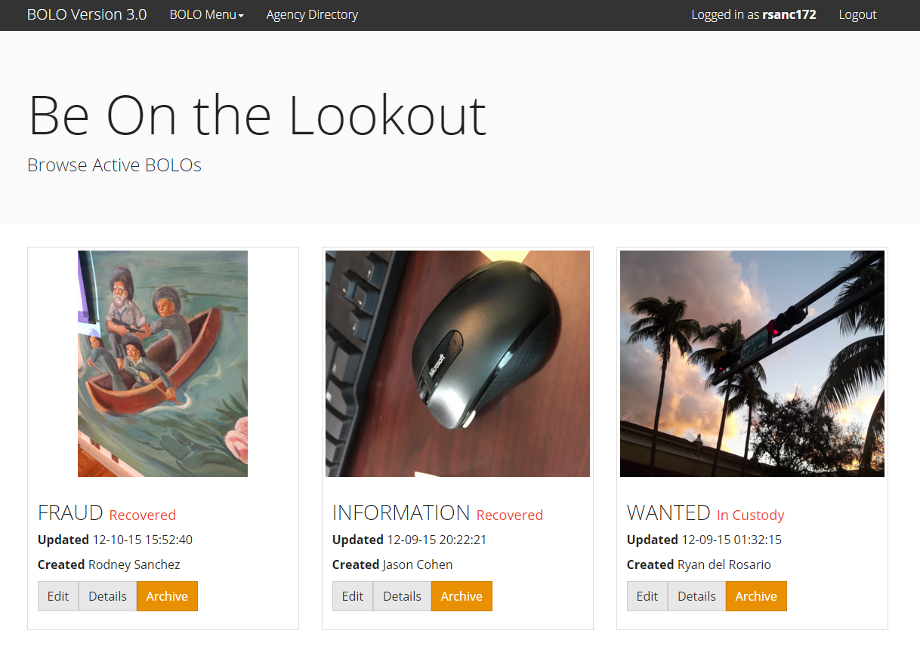

Figure Active Bolo List

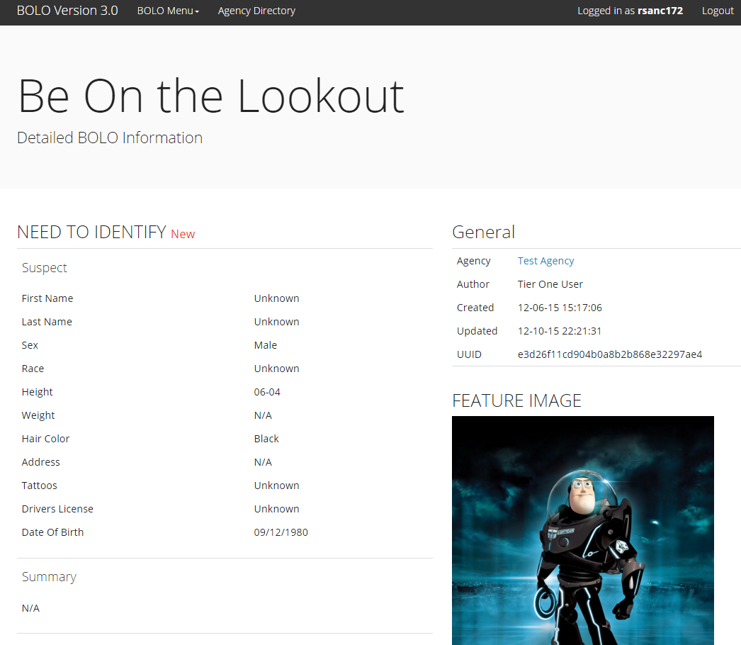

Figure Bolo Details

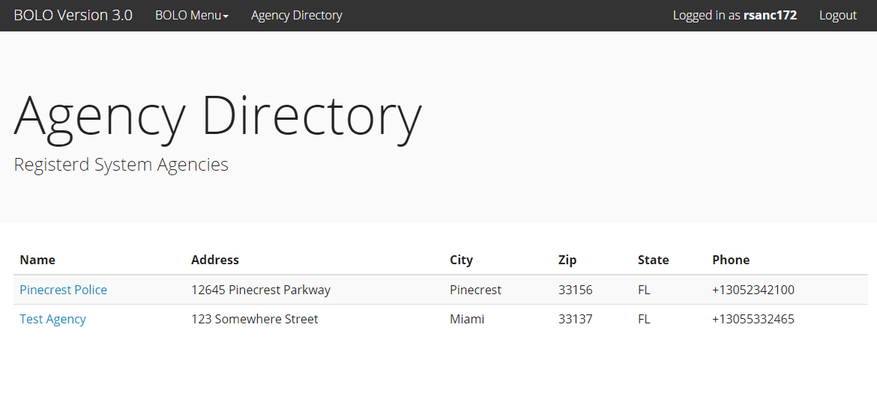

Figure Agency Listing

## 

## Appendix C: Sprint Review Reports

### Sprint 1 Report

**Date:** September 11, 2015

**Attendees:** Rodney Sanchez, Ryan del Rosario

**Discussed Topics:**

Rodney presented our overall goals for Sprint 1. He explained the technologies that we needed to learn and how they fit into the project. He also explained how some of our design decisions are pending on some of the costs involved with bringing the system into production on the Bluemix platform.

Ryan showed the work we have done in refactoring the current state of the system. The prototypal nature of the current system would have made it difficult to work with. The current Version 3 system was broken down into modules that could be added and removed and also refactored to use a Singleton Cloudant connection object.

We also presented our attempt to organize the project. We needed a way to get a general overview of what has been done in previous BOLO versions. We presented our spreadsheet exported from previous Mingle User Stories that organizes them into an easy to view grouping of importance. Professor Sadjadi thinks this was a good idea and would like to see it replicated in Mingle. Professor Sadjadi also helped us set up Mingle for Sprint 2.

We asked for guidance on how system design should be carried out in a Scrum environment. It was suggested that design should be an evolutionary process that is guided by the order of user stories done in each sprint. It was also suggested that there is sometimes a need to restructure the design. Professor Sadjadi commented on our progress understanding that the slow start is attributed to the nature of the project and external factors driving the direction of the project.

### Sprint 2 Report

**Date:** September 26, 2015

**Attendees:** Rodney Sanchez, Ryan del Rosario

**Discussed Topics:**

Rodney Sanchez presented the user story implementation details along with the infrastructure required to implement the user story in the chosen architecture. Presented the front end system interface for the application which implements the create bolo feature.

Ryan del Rosario presented the Hexagonal Architecture that was chosen for the project and the decisions for choosing it. Talked about the reorganization of the product backlog using Gherkin language and the combining of similar cards using scenarios in order to provide a base for the BDD/TDD workflow.

We were warned that we are off to a slow start and that moving forward we should be presenting user stories implemented individually.

### Sprint 3 Report

**Date:** October 9, 2015

**Attendees:** Rodney Sanchez, Ryan del Rosario

**Discussed Topics:**

Rodney Sanchez showed off work he had done on the Edit and List BOLOs pages. He showed off the code involved with implementing those features. He also showed our meeting minutes.

Ryan del Rosario talked about the difficulties in uploading files to the system. He mentioned to the professor the many technical challenges with storing binary files into a database. He then showed the library that he implemented for Object Storage.

Other Notes, not everything was completed for this Sprint. The professor mentioned that this happens and when it does that it common practice to re-evaluate and decide whether to put it back on to the product backlog or move it into the next Sprint.

### Sprint 4 Report

**Date:** October 23, 2015

**Attendees:** Rodney Sanchez, Ryan del Rosario

**Discussed Topics:**

Rodney started off with explaining the challenges we faced in implementing the bolo features concerning the handling of images. In particular, he talked about how we are unsure of how to approach the problem but explained that we were reaching out to our mentors. He then proceeded with discussing the sequence diagrams for the Delete Bolo and Edit Bolo story cards that he worked on for this sprint. Next Rodney showed presented the code that he worked on to implement his assigned tasks. Finally, he gave a demonstration of the working implementations minus the image attachments.

Ryan started off with explaining his difficulties in finding an authentication COTS component for Node.js and ExpressJS projects. Then he explained the approach that he took to implement the Login and Logout functionality. He presented the sequence diagrams showing how his solution works from a high level. Then he showed the tests and proved that the tests are running successfully and explained the tests. He also showed the code associated with the implementation of the Login and Logout functionality. Finally, he gave a demo of the features working.

### Sprint 5 Report

**Date:** November 6, 2015

**Attendees:** Rodney Sanchez, Ryan del Rosario

**Discussed Topics:**

Ryan started off by giving an overview of his work during this sprint and explaining the task breakdown of his assigned user stories. He explained the difficulties he experienced and the suggestions made by the technical mentors in how to approach a solution. Next Ryan presented updates to the sequence diagrams in which attachments for bolos have been added. He explained that the original strategy using IBM Object Storage has been removed in favor of Cloudant document attachments as suggested by Robert.

Following the presentation of the diagrams Ryan executed the tests to show that all features have been unit and integrated tested and are currently passing. Then he began detailing the code for the features implemented this week. Running low on time, Ryan glossed over some key points and then moved on to the demonstration.

Rodney starting by giving an overview of our goals for this sprint. He then went over the cards on Mingle to show the task breakdown for his assigned user stories. He then went over the sequence diagrams showing how the architecture we have used has given us a process to follow when creating new features. He explained that because of our design most features follow the same execution path at a high level. He then went over the code implemented this sprint. He touched on some key points explaining things like validation and persistence using Cloudant. Finally, he gave a demo of the features tested. He also mentioned selenium tests created.

Other Notes, from our feedback from the professor we should be more in touch with our product owner and business owners. For the next sprint review we should be able to report that everyone is happy with our progress and glad that we are on board.

### Sprint 5 Report

**Date:** November 20, 2015

**Attendees:** Rodney Sanchez, Ryan del Rosario

**Discussed Topics:**

Ryan started working on the user management functionality, he got a lot of work done but because he could not finish by the end of the sprint, the stories he was working on were moved to the next sprint.

Rodney started working on the create agency functionality but since it was not completed at the time we reviewed this print it was decided to move it to the next sprint.

### Sprint 6 Report

**Date:** October 9, 2015

**Attendees:** Rodney Sanchez, Ryan del Rosario

**Discussed Topics:**

Ryan started by doing a recap of where the application was at the last print review meeting and listing the feature he worked on during the current sprint. He went in details over the user management functionality, showing that it would be available only to users with the appropriate permissions and explaining all the management of users that from there could be done. He also talked about how the navigation menu was organized now in a more convenient way especially to access t from mobile devices.

Rodney went over the create/edit agency functionality, explaining all the efforts required to get this functionality working, he also mentioned that the delete agency was not implemented because still no clear how the product owners want to proceed with that. Also the view Bolo details was implemented where we show in full detail all the information, pictures included of any bolo in the system.

### Sprint 7 Report

**Date:** October 9, 2015

**Attendees:** Rodney Sanchez, Ryan del Rosario

**Discussed Topics:**

Ryan worked during this sprint on the user permissions, making sure every user is able to access only what it supposed to. Also he worked on the notification sending functionality he got it working using send grid, now every time a bolo is created or modified and email notification is sent to the subscribed users.

Rodney worked on the paging for the BOLO and ARCHIVE listing pages and was able to get it working properly. Also a new Archive page was created as well as the ability to either restore or destroy a bolo, an important issue regarding to the attachments on the edit BOLO was fixed so the user could be able to replace images from the BOLO, delete existing ones or adding extra images.

## Appendix D: Sprint Retrospective Reports

### Sprint 1 Retrospective

**Date:** September 11, 2015

**Attendees:** Rodney Sanchez, Ryan del Rosario

**Discussed Topics:**

After we finish the meeting with Juan, Robert and the rest of the team, we had a lot of questions, regarding to architecture, organization, implementation and deployment that could not be answered because an estimate with the costs from the Bluemix guys would be needed in order to start coding the system in one way or the other

We need to figure out the best way to implement the CRUD operations using Cloudant and express. NoSQL databases seems to have some limitations because of its nature, the document update process can be tedious and sometimes can cause consistency problems, especially if multiple nodes are being used with a load balancer server.

Since Cloudant is based on couch DB, and the documentation about Cloudant if somehow limited we are trying to understand couch DB and from there should be easier to start using Cloudant.

### Sprint 2 Retrospective

**Date:** September 26, 2015

**Attendees:** Rodney Sanchez, Ryan del Rosario

**Discussed Topics:**

Even though the project is off to a slow start we believe that moving forward user stories should be easily implemented in the Ports and Adapters system architecture that we have set up. Most of this work was to ensure that changes influenced by factors outside of our control, e.g. Platform, Client Devices, County IT Restrictions, etc.

### Sprint 3 Retrospective

**Date:** October 9, 2015

**Attendees:** Rodney Sanchez, Ryan del Rosario

**Discussed Topics:**

One of the biggest issues in this sprint was our gross underestimation of the difficulty and work required for certain features. Originally the image upload feature was lumped in together with the Create BOLO feature. It was estimated that the feature would not require much effort. This underestimation caused a negative cascading effect on other cards that were set for this Sprint but have a dependency on the underestimated feature.

One of our goals for this next Sprint is to re-evaluate our estimated points on cards during the card grooming phase. The hope is that we can better estimate card points and with a more realistic estimation. We also want to look into the dependencies of each feature (and their corresponding tasks) to ensure that we understand how the features relate. This should hopefully give us a more useful burn rate.

### Sprint 4 Retrospective

**Date:** October 23, 2015

**Attendees:** Rodney Sanchez, Ryan del Rosario

**Discussed Topics:**

Looking over the past few sprints we realize that the greatest risk in this project is our unfamiliarity with the technologies and the standard approaches used in those technologies. After our meeting with Juan on Thursday we have decided to put in some effort to refactor and clean up the project so we can present a more organized project to Robert, our technical mentor. With this hopefully we can gain some insight as to how we can implement image attachments without a file system. We have also leveraged our connection with David Jaramillo of the IBM CIO office to see if they could give us any insight to our issue.

### Sprint 5 Retrospective

**Date:** November 6, 2015

**Attendees:** Rodney Sanchez, Ryan del Rosario

**Discussed Topics:**

Based on the work we went over we will continue our progress as usual. Changes we are making to our workflow are to put more effort into getting in contact with our mentors and product owners. The other thing we will strive for is to leverage our technical mentors to reduce our time researching into COTS solutions, best practices, and technology specific solution strategies.

### Sprint 6 Retrospective

**Date:** October 9, 2015

**Attendees:** Rodney Sanchez, Ryan del Rosario

**Discussed Topics:**

We got a good amount of functionality working such as the listing, create and edit functions for the agencies, we feel this was a big step. Also the bolo details page was completed and the user management section was even more refined.

### Sprint 7 Retrospective

**Date:** October 9, 2015

**Attendees:** Rodney Sanchez, Ryan del Rosario

**Discussed Topics:**

During this sprint we have done quite a bit of work, we were able to get a lot done. Paging was implemented for the Bolo and Archive listing pages, some serious bugs were fixed such as being able to replace attachments on the BOLO edit functionality, also the displaying of a notification when the bolo was updated was implemented, everything was completed on time and at this point we feel we have usable system that need couple of more features and some refinement but overall is robust and well design, tested and working.

# References

*Hexagonal Architecture* Alistair Cockburn. http://alistair.cockburn.us/Hexagonal+architecture

*What’s in a Story?* Dan North. http://dannorth.net/whats-in-a-story

*Visualizing Test Terminology* Nat Pryce. http://www.natpryce.com/articles/000772.html

*The Birthday Greetings Kata* Matteo Vaccari. http://matteo.vaccari.name/blog/archives/154

*The Clean Architecture* Bob Martin. http://blog.8thlight.com/uncle-bob/2012/08/13/the-clean-architecture.html

# Tools, Frameworks, Platforms

Node.js, https://nodejs.org/en/

Intern Testing Framework, https://theintern.github.io/

Express.js, http://expressjs.com/

IBM Bluemix

IBM Cloudant

1. https://www.nginx.com/blog/introduction-to-microservices/